Algebra 1: Unit 6, Lesson 2

- A compound inequality is shown.
$$-6≥6x>42$$What is the solution for the compound inequality?

$$-1≥x>7$$

- A compound inequality is shown.
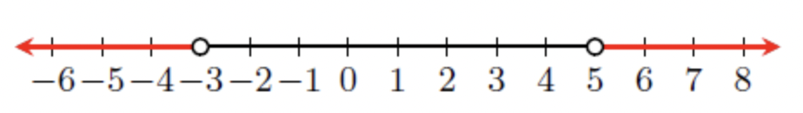
Write the inequality.

$x<-3$ or $x>5$
- A compound inequality is shown.
$$-7<7x≤42$$Complete the statements.
To solve the compound inequality, rewrite the compound inequality as the two single inequalities then, divide both sides of each inequality by _______________.

7

